Assignment 1:

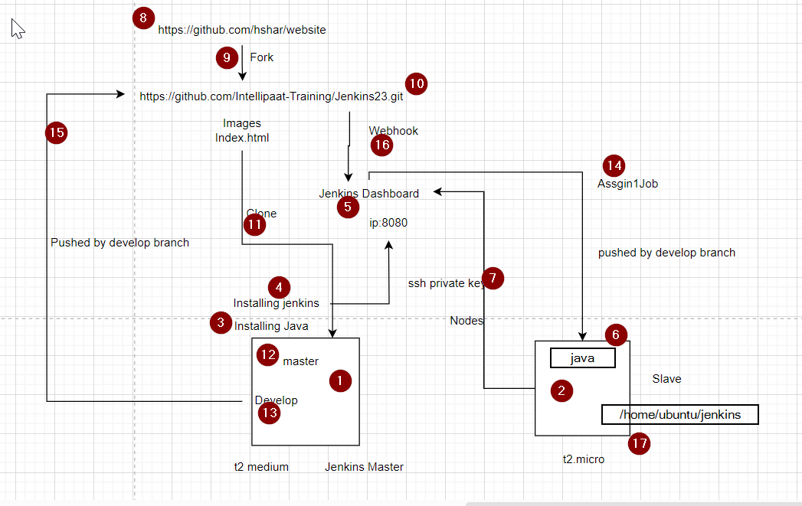

<https://www.jenkins.io/doc/book/installing/linux/#debianubuntu>